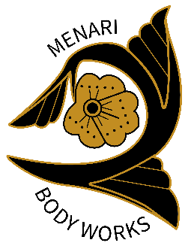
COVID-19
Cleaning Procedures:

Between Clients:
- Open door and put stopper rock to hold it open during the cleaning time block allotted post session (keep AC running)
- Wipe down all shared surfaces: ipad, tablet for checking out, door handles (inside and out) bathroom handles (tap, toilet, light switch, door knobs) table warmer control, plate for hot towels, shelf for clients, hooks for clients, hand sanitizer bottle and pump, water dispenser handle, chair for client to sit on in room

- Wipe down the back bar counter, the dropper for the EO used, handles for the drawers used and the hot cabbie handles, oil bottle (if used) lotion tube (if used)
-use gloves to handle any dirty laundry produced by the client or yourself during the cleaning procedures

Table/ room setup:
- use plastic sandwich bag to cover the eye pillow for each client
- use one of the foot treatment bags to cover the neck roll for the day, wipe down after each client

Uniform:
- Change your uniform completely between clients, removing it in such a manner as to reduce exposure.
- Do not remove your mask until you have removed a much clothing as possible, then remove your mask washing your hands before and after.
- Use a new N95 mask per each client, and sanitize the face shield in between clients.
- Use a warm soapy wash cloth to clean any exposed skin in between clients. Place in plastic laundry bins (not in the bathroom basket)

End of the day Cleaning:
- Change into a new pair of clean gloves before you begin cleaning.
- Place all N95 masks in assigned brown paper bag and mark with the date.
- Do end of day post-client cleaning, including the phone, keyboard, table and all light switches and doorknobs, as well as the bathroom and any other surfaces clients came in contact with.
- Dump laundry from the dirty bin for washing into the grey bin and wipe inside and outside with sani wipe.
- Wipe down the controls for the AC and the step ladder
- Pull bags of all trash cans then use sani wipes to wipe the inside and outside of the garbage can thoroughly. Throw away the trash on your way to your car.
- Change your clothes from uniform to street clothes before you leave and take home your work clothes for cleaning in a designated bag.

